# UAV Routing Problem

Subject : Unmanned Aerial Vehicul routing problem with charging stations for autonomous inspection system in the mining industry.

Mine :

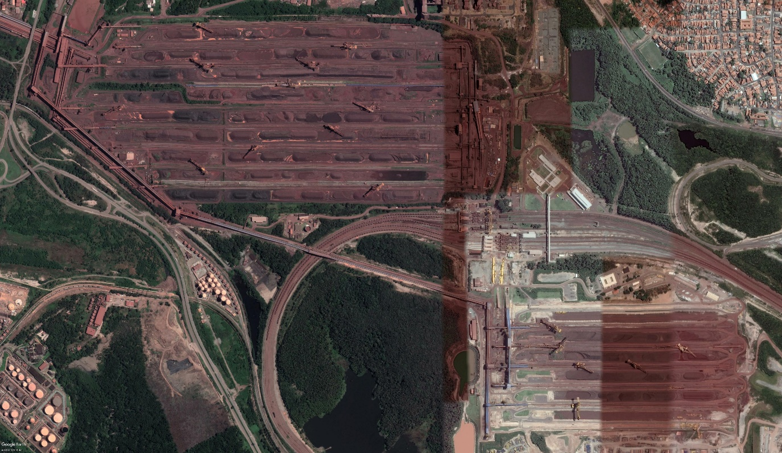

Every node’s position to inspect are written in a text file.

The aim is to create the shortest route visiting each node one time.

To do this, I used metaheuristics and heuristics.

Two metaheuristics :

* Genetic algorithm
* ALNS (Adaptive Large Neighborhood Search)

Each one has it’s pros and cons.

All the code is written in Python and for the moment we need to execute the program in command line.

When executing, the program will apply a metaheuristic (there is one command for each algorithm). The options (percentage of nodes used, number of iterations, size of the population for genetic, drones autonomy) are hard written in the code for test purposes. It will be changed.

The options are set for test purpose, I use 20% of the nodes an not too much iterations in order to make the program not too long to execute (less than a minute). There is more than 900 nodes, if we use them all the execution is realy long. This is why I’m currently working on optimisation.

It will then show the result in a canevas to get an idea of the drone’s route.

Example :

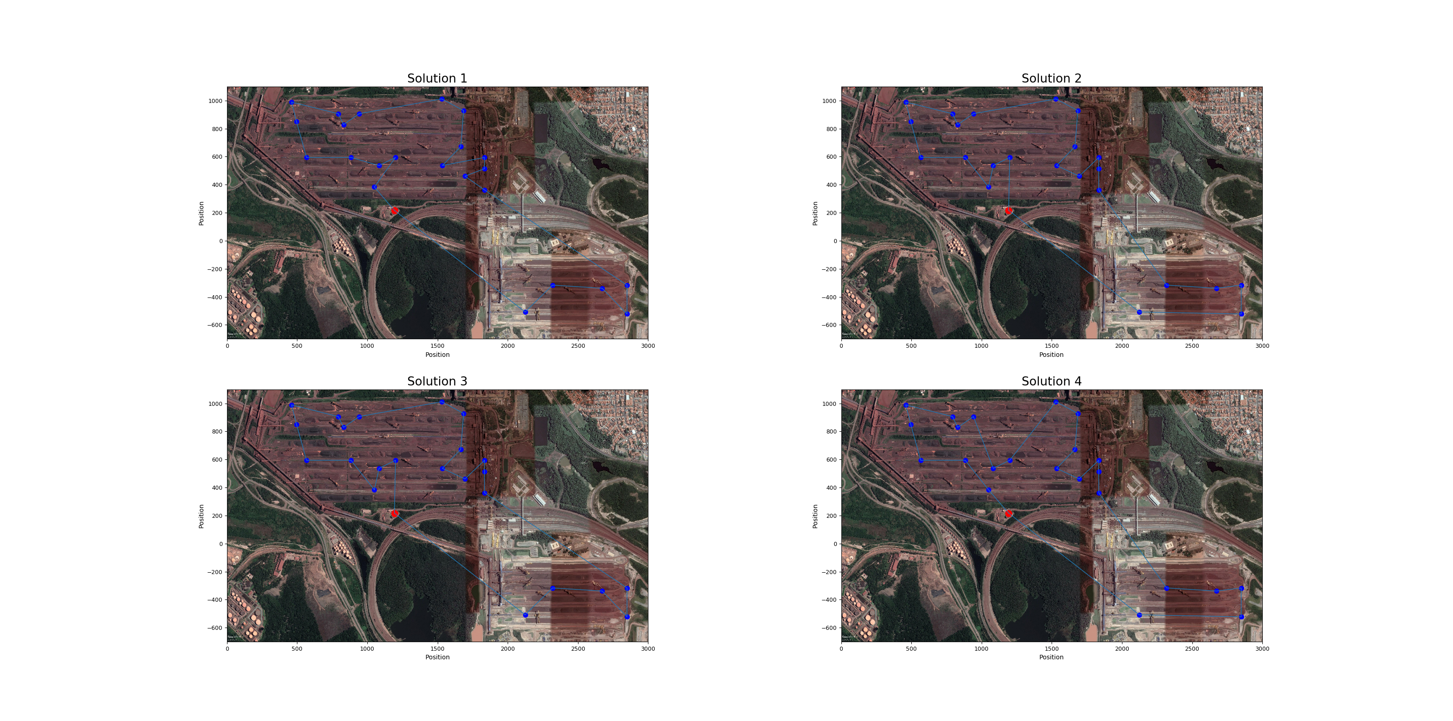

Example with all points (1h of execution, could be a lot better when optimisation will be finished) :

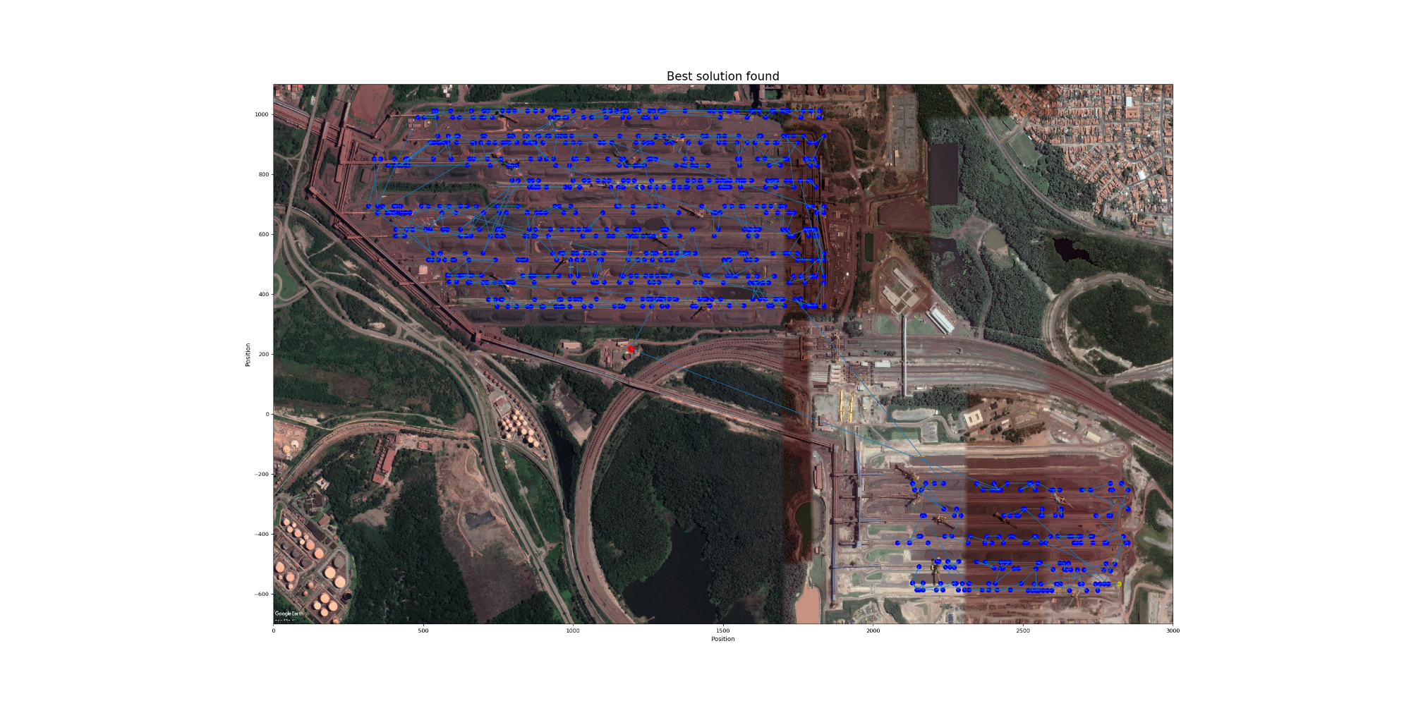

To execute the program in the command line, you need to be in the main folder (UAV_routing) and use one of these command :

py mainGenetic.py

py mainALNS.py

Python 3.7 and some modules listed in files are needed.

It will all be explained in detail in my traineeship report, which will be available the 20th of August.